**Assignment-3**

|  |  |
| --- | --- |
| **Date** | 30 October 2022 |
| **Team ID** | PNT2022TMID05082 |
| **Project Name** | Inventory Management System for Retailers |
| **Batch No** | B11-5A1E |

**1.Create a Bucket in IBM object storage.**

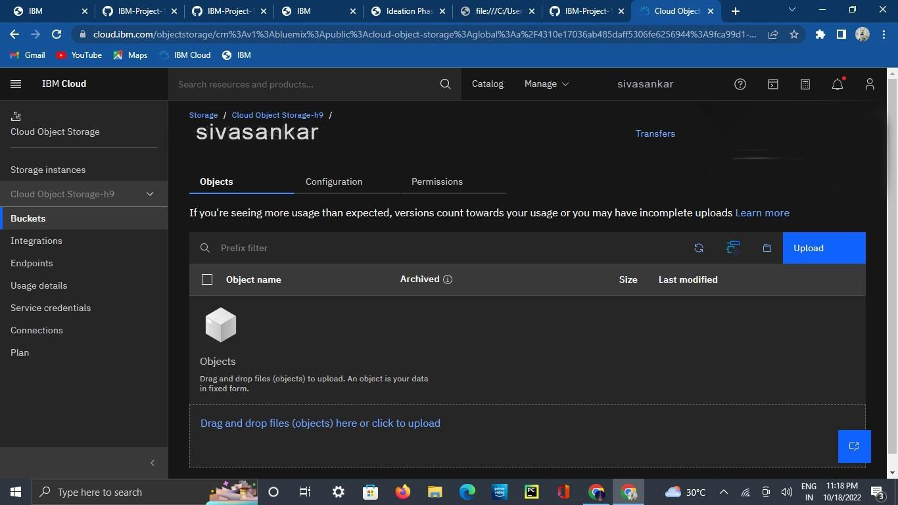

**2.Upload an 5 images to ibm object storage and make it public. write html code to displaying all the 5 images.**

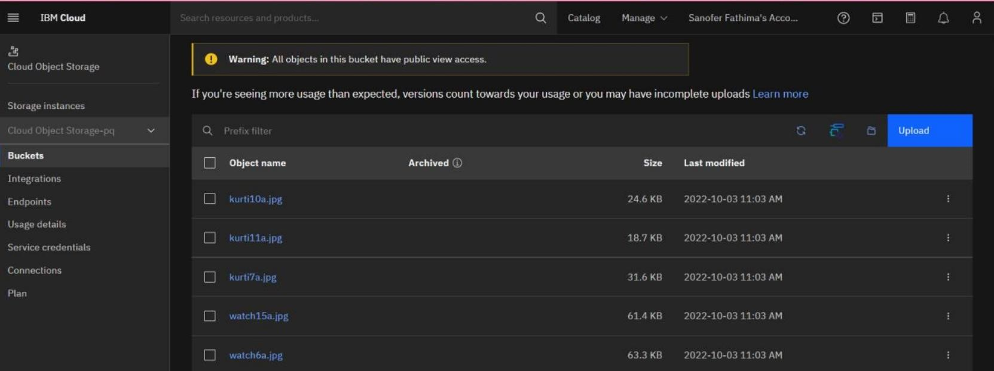

**Display.html**

<!DOCTYPE html>

<html lang="en">

<head>

<meta charset="UTF-8">

<title>ASSIGNMENT</title>

<link rel="stylesheet" href="{{url_for('redirect_to',link='https://s3.jp-tok.cloud-objectstorage.appdomain.cloud/sanrasheedcss/assign3.css')}}" type="text/css">

</head>

<body >

<h1>DISPLAYING IMAGES FROM CLOUD OBJECT STORAGE</h1>

{% for image in arr: %}

<img src="{{url_for('redirect_to',link=image)}}">

{% endfor %}

</body>

</html> **App.py**

from flask import Flask,render_template,request,redirect,url_for from connect import * from objstorage import * app= Flask(__name__) @app.route("/assign3") def objstorage(): for i in range(0,len(imagearr)):

imagearr[i]="https://s3.jp-tok.cloud-objectstorage.appdomain.cloud/sanrasheed29/"+imagearr[i] print("objstorage ", imagearr)

return render_template('assign3.html',arr=imagearr)

@app.route('/redirect_to') def redirect_to():

link = request.args.get('link', '/') return redirect(link), 301 if(__name__=='__main__'): app.run()

**Output:**

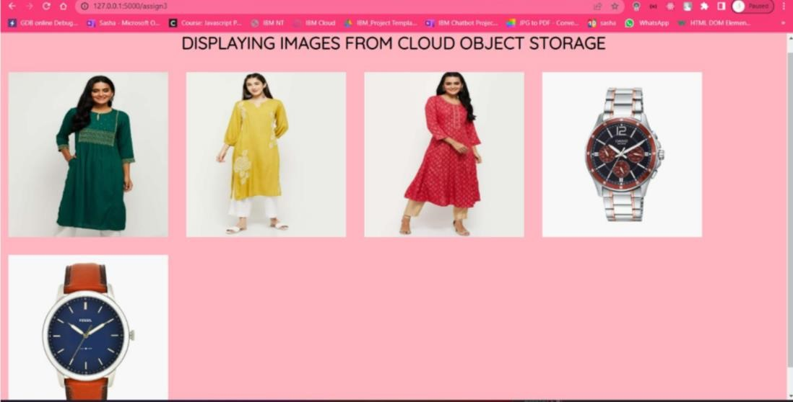

**3.Upload a css page to the object storage and use the same page in your HTML code.**

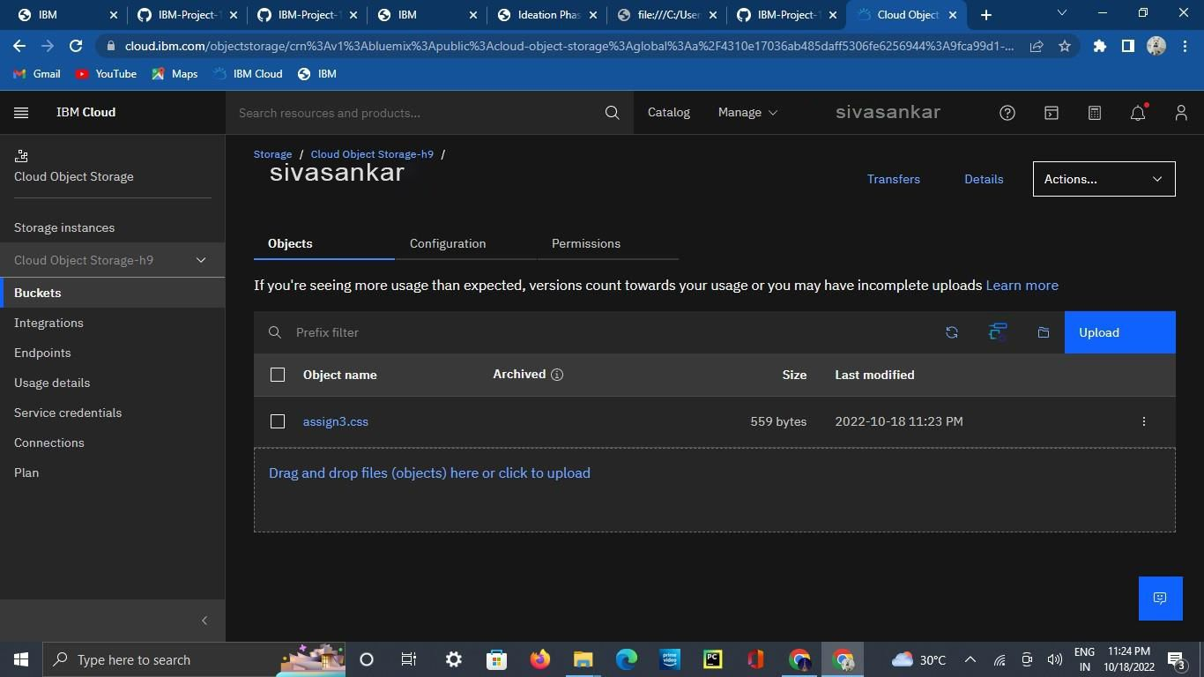

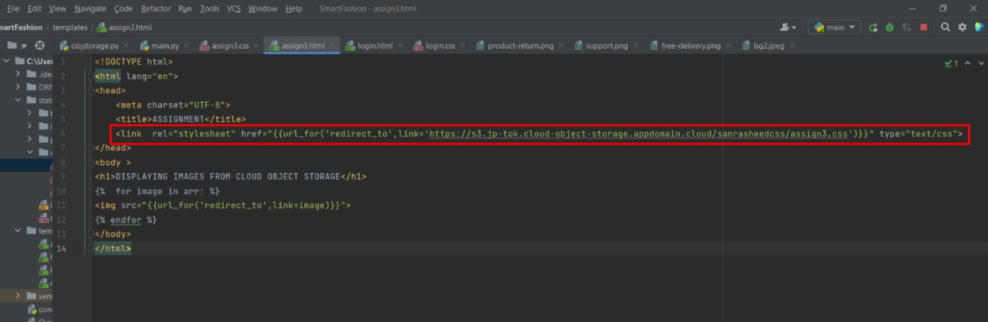

**4.Design a chatbot using IBM Watson assistant for hospital.**

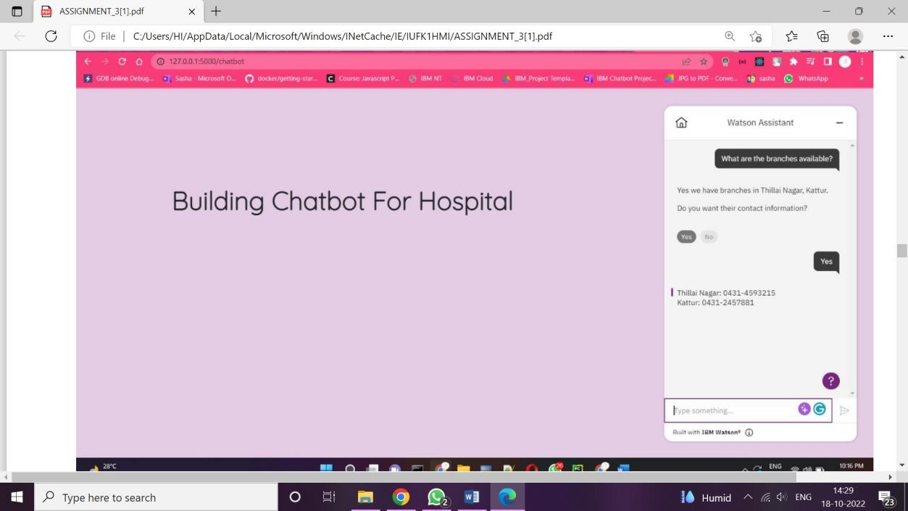

**Web URL for Assistant:**

<script>

window.watsonAssistantChatOptions = { integrationID: "cba0c163-9f9a-42ce-b6e9-979ac6318cc0", // The ID of this integration. region: "au-syd", // The region your integration is hosted in.

serviceInstanceID: "245858a6-01a2-41fc-8707-d603be17b8f0", // The ID of your service instance.

onLoad: function(instance) { instance.render(); }

};

setTimeout(function(){

const t=document.createElement('script');

t.src="https://web-chat.global.assistant.watson.appdomain.cloud/versions/" +

(window.watsonAssistantChatOptions.clientVersion || 'latest') +

"/WatsonAssistantChatEntry.js"; document.head.appendChild(t);

});</script>

**5. Create Watson assistant service with 10 steps and use 3 conditions in it. Load that script in HTML page.**

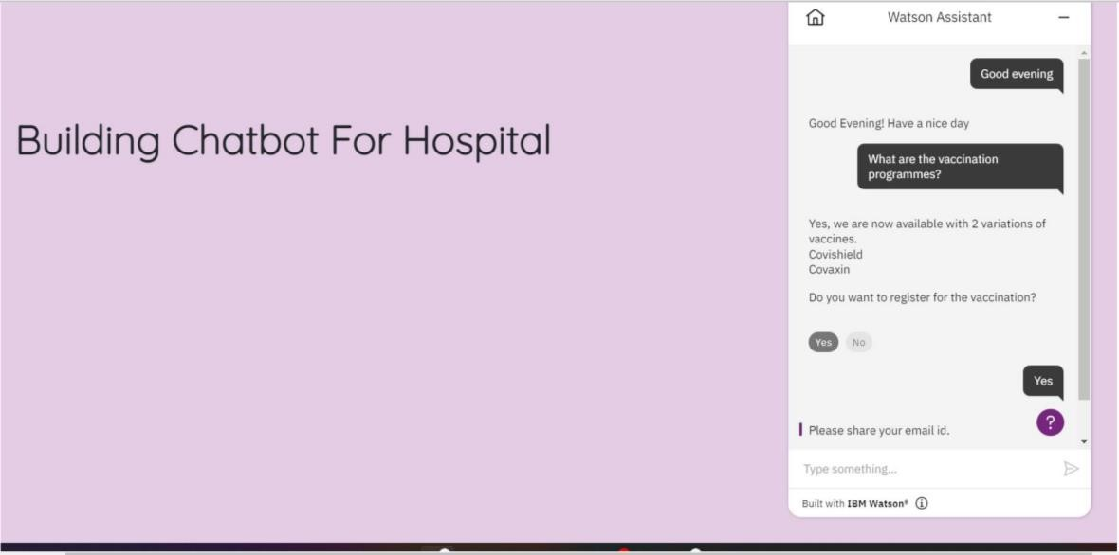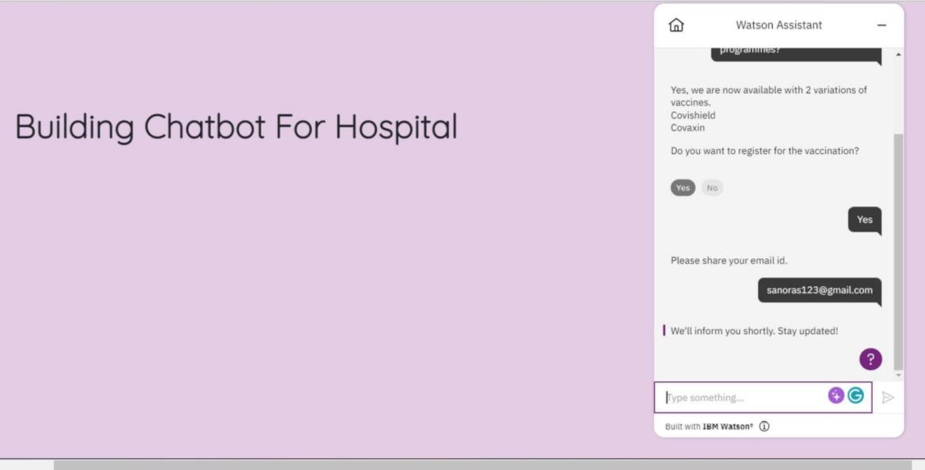

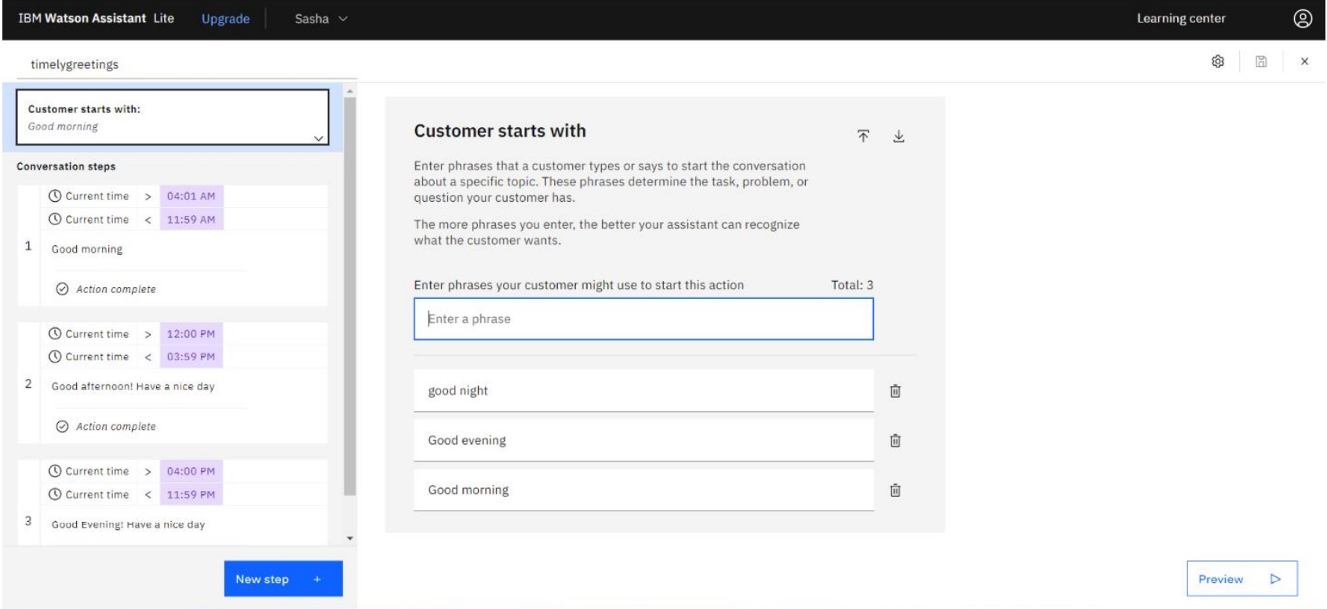

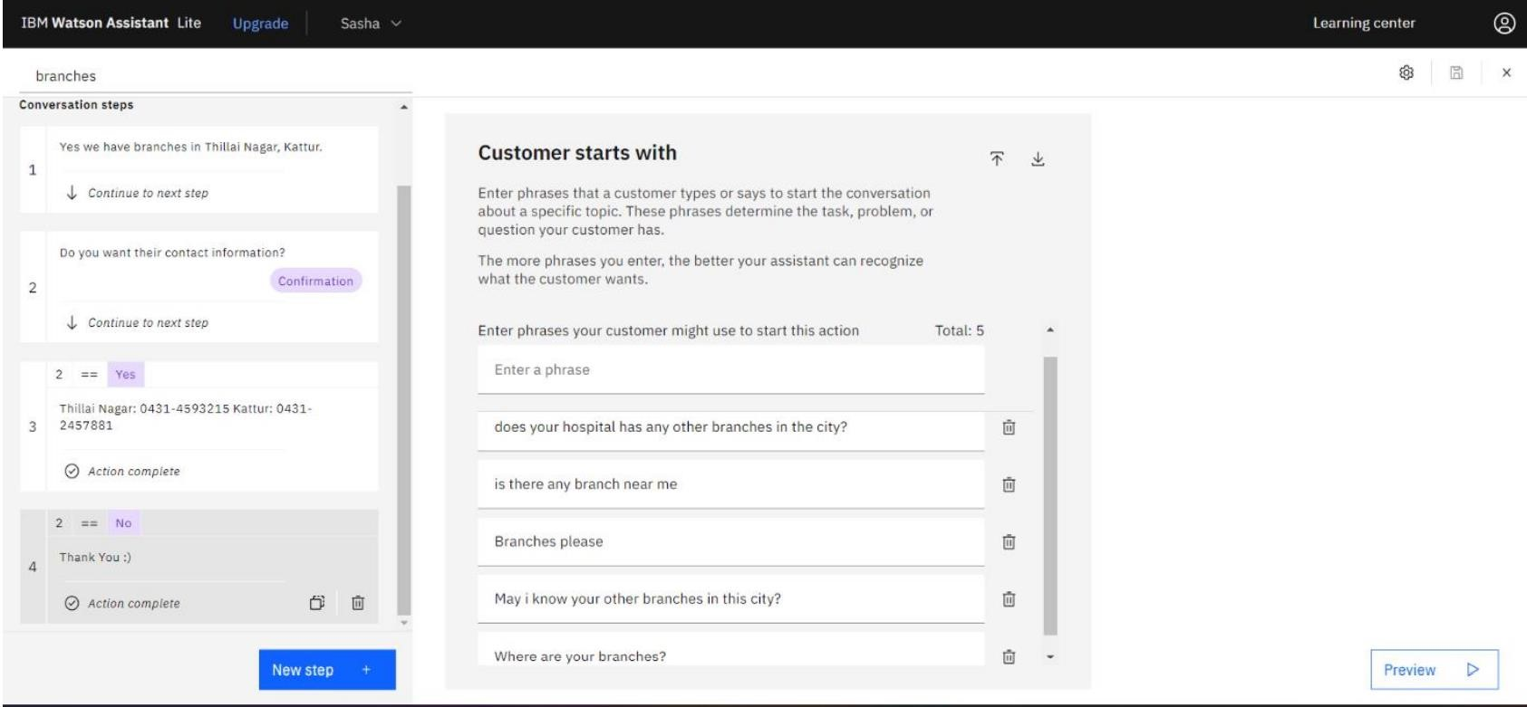

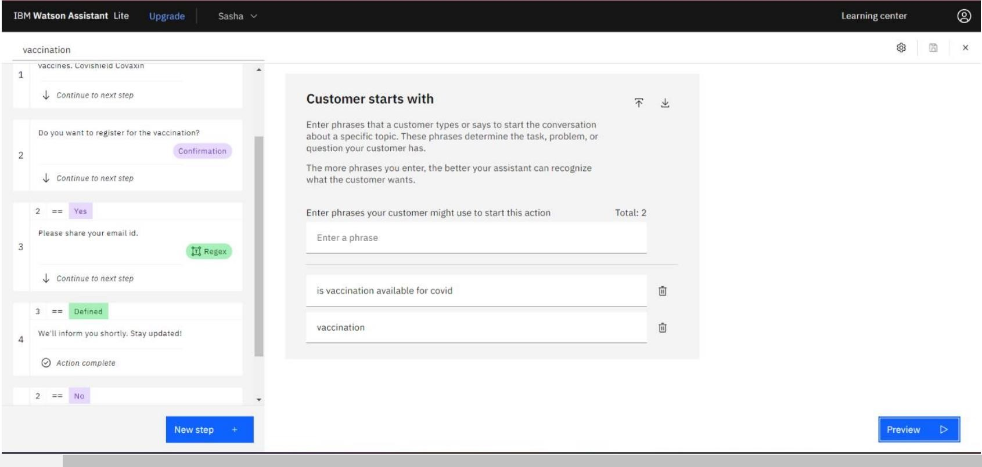

**Html code:**

<!DOCTYPE html>

<html><head>

<meta name="viewport" content="width=device-width, initial-scale=1.0">

<title>Chatbot </title>

<link rel="stylesheet"

href="https://cdn.jsdelivr.net/npm/bootstrap@4.6.2/dist/css/bootstrap.min.css" integrity="sha384-

xOolHFLEh07PJGoPkLv1IbcEPTNtaed2xpHsD9ESMhqIYd0nLMwNLD69Npy4HI+N" crossorigin="anonymous">

<link rel="stylesheet" href="{{url_for('static',filename='styles/login.css')}}" type="text/css">

<link rel="preconnect" href="https://fonts.googleapis.com">

<link rel="preconnect" href="https://fonts.gstatic.com" crossorigin>

<script defer src="https://use.fontawesome.com/releases/v5.13.1/js/all.js"></script>

<link

href="https://fonts.googleapis.com/css2?family=Alex+Brush&family=Quicksand:wght@300 &display=swap" rel="stylesheet"></head>

<body style="background:rgba(128,0,128,0.2"> <h1 style="font-weight: bolder; margin: 12%;

font-size: xxx-large;">Building Chatbot For Hospital</h1> <script> window.watsonAssistantChatOptions = { integrationID: "cba0c163-9f9a-42ce-b6e9-979ac6318cc0", // The ID of this integration. region: "au-syd", // The region your integration is hosted in.

serviceInstanceID: "245858a6-01a2-41fc-8707-d603be17b8f0", // The ID of your service instance.

onLoad: function(instance) { instance.render(); }}; setTimeout(function(){

const t=document.createElement('script'); t.src="https://webchat.global.assistant.watson.appdomain.cloud/versions/" + (window.watsonAssistantChatOptions.clientVersion || 'latest') +

"/WatsonAssistantChatEntry.js"; document.head.appendChild(t);

});</script>

</body></html>